2015 WoW Conference Location
- Locations

a. Workshop: KI Building (at KAIST)

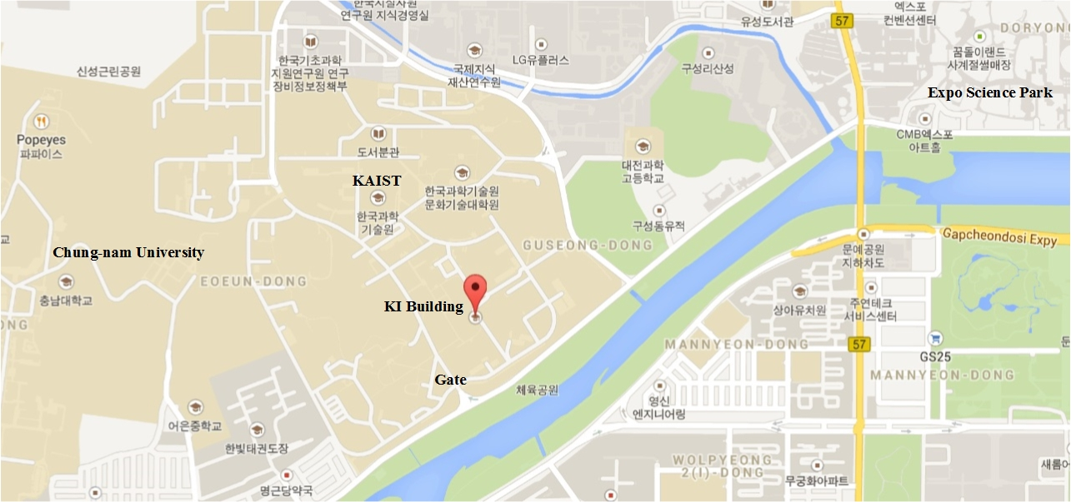

<Click to the Google-map>

- KI Building (E4), KAIST 291 Daehak-ro, Yuseong-gu, Daejeon, 305-338

b. Accommodation : Lotte City Hotel Daejeon

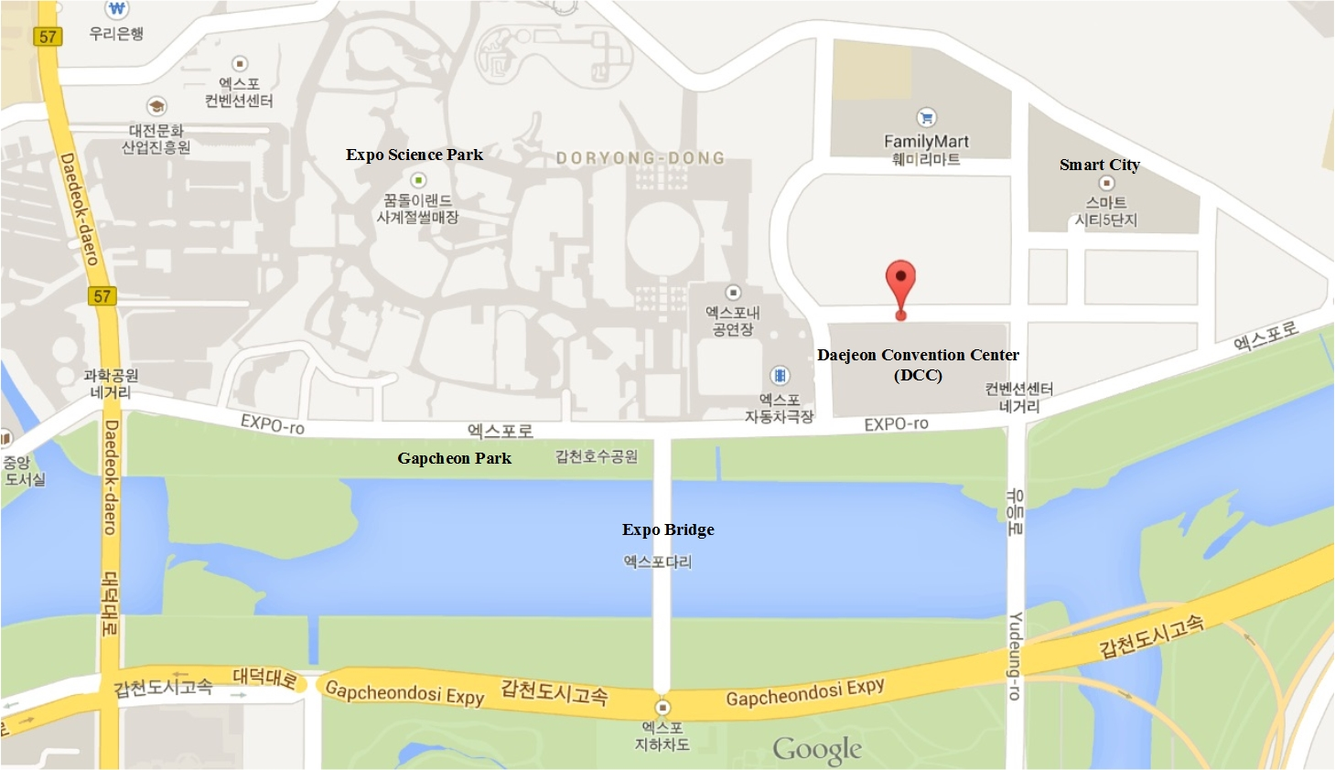

<Click to the Google-map>

- Lotte City Hotel Daejeon, 33, Expo-ro 123beon-gil, Yuseong-gu, Daejeon, Korea

- TEL : +82-42-333-1000 / FAX : +82-42-333-1050

- Directions
- Incheon Airport → KAIST KI Building or Lotte City Hotel

- The limousine bus to Daejeon leaves the airport at the regular intervals, as shown in the following, and arrives in Daejeon near the Government Complex Building at the third stop before terminating at the Daejeon Eastern Express Bus Terminal. When the bus exits from a high way, the announcement is conducted and there are 4 bus stops in Daejeon city and the third stop “Government Complex Building” is the nearest stop to take a taxi to KAIST campus or Lotte City Hotel.

- Limousine bus boarding place : Bus stop “#9D” in front of the arrival terminal at the Incheon airport

(it takes about 3 hours)

- Fee of the limousine bus : KRW 21,300

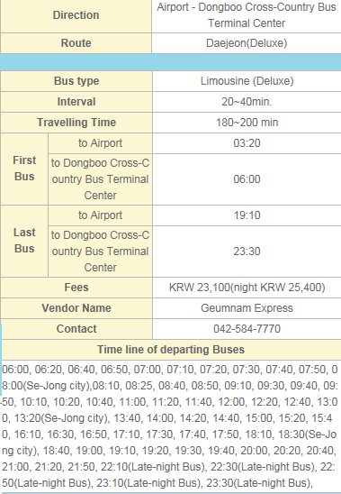
<Click for the detail content>

  - Daejeon Government Complex Building → KAIST KI Building

- Transportation fee: KRW 4,000 by taxi (it takes about 5 min.)

- Address: KAIST KI Building, 291 Daehak-ro, Yuseong-gu, Daejeon, 305-701, Korea

(In Korean, 카이스트 KI빌딩)

  - Daejeon Government Complex Building → Lotte City Hotel

- Transportation fee: KRW 3,000 by taxi (it takes about 3 min.)

- Address: Lotte City Hotel, 4-30, Doryong-dong, Yuseong-gu, Daejeon, 305-340, Korea,

(In Korean, 롯데시티호텔)

- ECCE-ASIA 2015 Venue (63 Building, Yeouido, Seoul) → KAIST KI Building or Lotte City Hotel
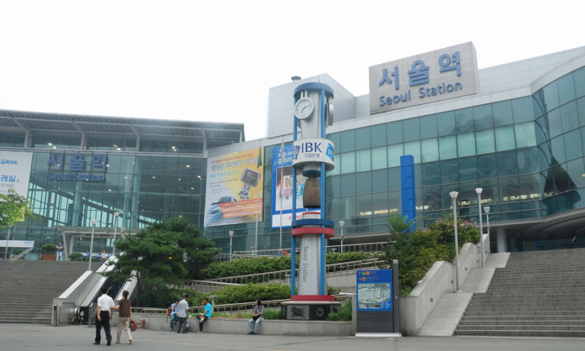

- ECCE-ASIA Venue (63 Building) → Seoul Station (KTX)

- Transportation fee: KRW 9,000 by taxi (it takes about 25 min.)

- Address: 43-205, Dongja-dong, Yongsan-gu, Seoul, Korea (140-821)

(In Korean, 서울역)

- Seoul Station (KTX) → Daejeon Station (KTX)

- Transportation fee: KRW 23,700 (http://www.letskorail.com/)

- Destination: Seoul to Daejeon (it takes about 1 hour)

(In Korean, 대전역)

  - Daejeon Station (KTX) → KAIST KI Building

- Transportation fee: KRW 10,000 by taxi (it takes about 25 min.)

- Address: KAIST KI Building, 291 Daehak-ro, Yuseong-gu, Daejeon, 305-701, Korea

(In Korean, 카이스트 KI 빌딩)

  - Daejeon Station (KTX) → Lotte City Hotel

- Transportation fee: KRW 9,000 by taxi (it takes about 25 min.)

- Address: Lotte City Hotel, 4-30, Doryong-dong, Yuseong-gu, Daejeon, 305-340, Korea,

(In Korean, 롯데시티호텔)

